33Done by: Yazan Khoury  
instructor: Doctor Fawaz Khasawneh  
CRP: computing research project

**Future development and driving innovation in Big Data**

Introduction:

Big data has been rapidly growing within a short period, due to data’s sudden and unprecedented expansion. The fast-growing data has created many obstacles containing strengths and weaknesses of these technologies. Thus, some structuralism and functionalism paradigms are going to be used to analyze the origins of the big data application and its current trends.

In recent years, there has been a substantial increase in the volume of data that has been processed, expanding by a factor of nine. This growth may be mostly attributed to the demand from prominent corporations and organizations such as Yahoo, Google, and Facebook, who have sought to examine extensive datasets. The exponential growth of data has resulted in the emergence of "big data" as a prominent subject of interest, leading to extensive deliberations over its worth, potential, approaches, techniques, and financial commitments required to effectively leverage its capabilities. The management of large volumes of data necessitated the creation of novel technologies to facilitate storage, analysis, processing, and utilization. Machine learning and advanced statistical and analytical approaches have been developed to address the unique issues presented by big data. (yaqoob, et al., 2016) (jovana, 2019)

The concept of big data is commonly defined by the five V's. The concept of volume pertains to the quantity of data generated, and it qualifies as big data irrespective of its magnitude, provided that the data exhibits complexity. Velocity refers to the rate and characteristics of data produced by individuals or automated systems, typically in the form of unorganized data such as emails, video, and audio recordings. Value refers to the process of converting large amounts of data into valuable insights using advanced analytics techniques, hence improving the quality of decision-making. The concept of veracity pertains to the quality and correctness of gathered data, with a focus on not only data quality but also the intricacy and credibility of data sources. Consequently, the validation and analysis of such extensive data became necessary. (Nuguyen, 2018)

Big Data’s growth significantly impacted cloud computing and the Internet of Things, leading to a substantial increase in data volume. Due to that, enterprises have faced difficulties managing this vast and complex amount of data. These difficulties resulted from the recent increase in data and its complexity. Some are a result of big data's intrinsic qualities, while others are connected to the theories and techniques used in data analysis today. These difficulties are further exacerbated by the shortcomings in the data processing systems now in use.

(jin, et al., 2015)

Due to all of the challenges and problems that big data was facing, artificial intelligence has become very popular and is having a tremendous impact on the social, political, and economic spheres. However, artificial intelligence will also have a significant impact on the advancement and innovation of big data in the future. Technological advancements in data processing, analysis, and pattern recognition have affected the capacity to manage and fully utilize cast datasets. Artificial intelligence (AI) enhances the process of huge data analysis by automating complex tasks that would take a long time for humans to finish. The big data era, which has enormous implications for society and the economy, has been brought about by the rapid progress of technology and data. (Plantec, et al., 2023) (Nuguyen, 2018)

Artificial intelligence systems allow computer networks to improve performance as compared to an era of a non-Ai network system. Using this technology also affects business decision-making processes that would be too difficult to handle, and AI is able to handle all these big data analyses which offers an evolutionary advancement in many fields of research that focus on collecting large data sets.

In the consulting industry, operational insights are obtained by leveraging client data through strategic activities. This entails the processing of client preferences, decision-making trends, and interaction data using AI algorithms. In addition to absorbing this data, AI uses strict quality control procedures to address inconsistencies. In addition, AI and machine learning are essential for negotiating the complexities of consulting firms (Surya, 2021). The creation of quality prediction models and assessments for intelligent systems is essential to advancing intelligent consulting practices. The constant objective is to achieve excellent forecast accuracy and efficient simulation. Big data machine learning algorithms greatly improve these procedures and advance the consulting industry thanks to their data-rich capabilities. (Li et al., 2023). The application of machine learning for quality prediction in consulting is becoming more and more common, despite certain drawbacks. Machine learning has recently made progress in monitoring consulting processes, demonstrating its potential and usefulness in this rapidly evolving area. (Li et al., 2023).

**Literature Review**

The integration of Artificial Intelligence (AI) in the field of consulting has become imperative for businesses aiming to stay competitive and efficient. AI's ability to process vast amounts of data efficiently and enhance decision-making has positioned it as a transformative tool (Pelau, et al., 2021). It streamlines data, making it more manageable and accelerates decision-making processes. As technological advancements continue, non-adopters may face a widening performance gap, hindering their ability to keep pace with industry changes. McKinsey's study predicts that 70% of companies will adopt AI by 2023, emphasizing the urgency for companies to embrace these technologies or risk obsolescence (Lamarre, et al., 2023).

Deloitte, one of the leading consulting firms, has been at the forefront of AI integration for nearly a decade. Their AI system, developed internally, focuses on alleviating consultants from administrative tasks, allowing them to concentrate on advisory roles and significantly improving work quality through time efficiency. Machine learning, a key component of Deloitte's AI strategy, proves effective in handling extensive big data and generating optimal solutions. Thus, Deloitte utilizes GenAI, a generative artificial intelligence technology, for tasks like text completion and image generation, showcasing their commitment to cutting-edge AI applications. (Jane & Ganesh, 2019)

In practical cases, a government agency tasked with public procurement sought to enhance its vendor selection process. Facing inefficiencies in manually evaluating proposals, they embraced AI and ML. Historical data from diverse government entities was compiled, detailing past project outcomes. Data scientists engineered relevant features and developed a machine learning model. This model, trained on historical data, could predict optimal vendor proposals. Integrated into the procurement system, the AI-driven solution now automates proposal evaluations, saving time and ensuring consistency in decision-making.

In the Middle East, a government leveraged machine learning to optimize workforce management. Comprehensive employee data, including career paths and meeting outcomes, formed the basis for AI-driven recommendations. The system analyzed this data to generate personalized suggestions for onboarding, career trajectories, and optimal timing for vacations. By harnessing machine learning, the government enhanced employee experiences, promoting efficient onboarding, facilitating career growth, and ensuring well-timed vacations that align with both organizational needs and individual preferences.

Despite AI's rising prominence, the relationship between consultants and clients remains crucial. Building trust is essential, especially if clients are skeptical about technology. Deloitte's approach acknowledges that, for the foreseeable future, human jobs will not be replaced by machines. Instead, AI supports consultants, complementing human cognitive abilities.

The literature indicates that the adoption of AI in consulting is not only a technological necessity but a strategic imperative for organizations seeking efficiency, competitiveness, and improved client outcomes. Deloitte's extensive use cases and commitment to cutting-edge technologies position it as a leader in AI-driven consulting solutions.

“These cases and datasets were sourced in collaboration with Saleh Mwalla, a Deloitte manager, enriching the literature review with firsthand insights from an industry professional”

**Data analysis**

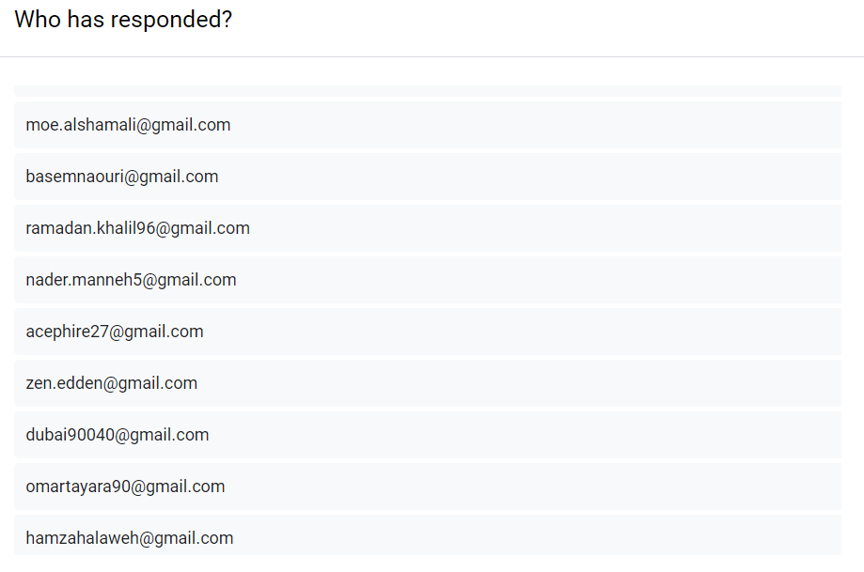

As it is shown in the attached photo, I was able to gather responses from different people working in different companies, not just Deloitte the company I am doing my research on.

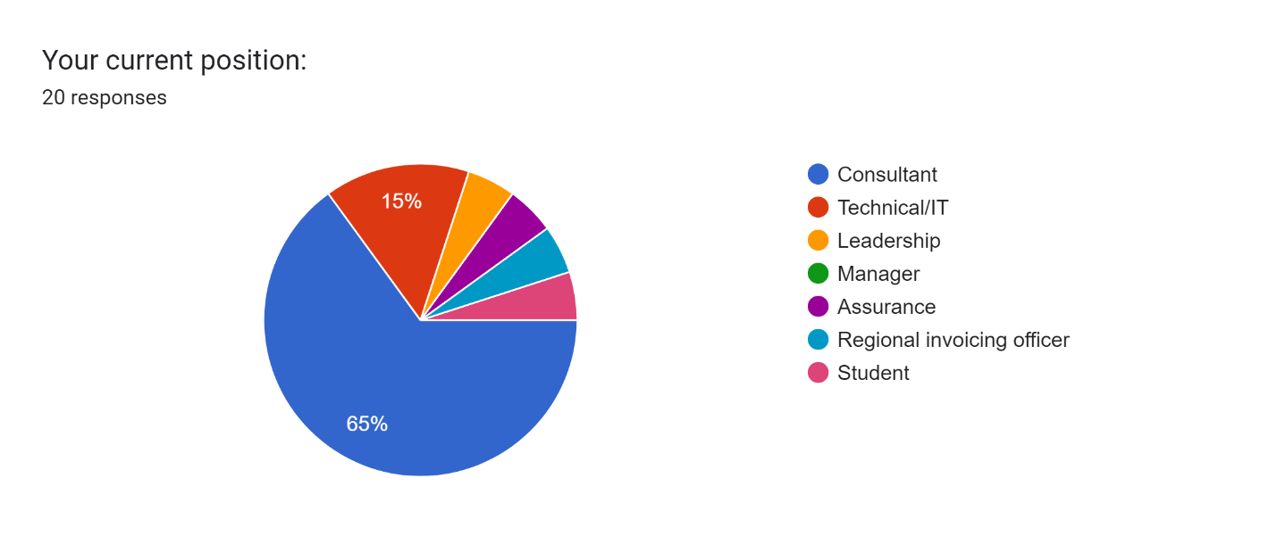

In the provided photo, the responses of this question are 65% are working as consultants and the others are technical IT which is 15%. I targeted those people due to my research purpose.

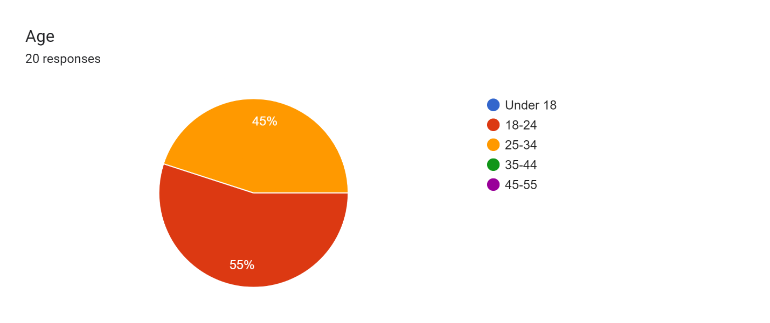

Here, it shows that most of the workers and trainers are between 18-34, and that is a good sign because young people nowadays knows more about the survey’s topic which is AL and ML.

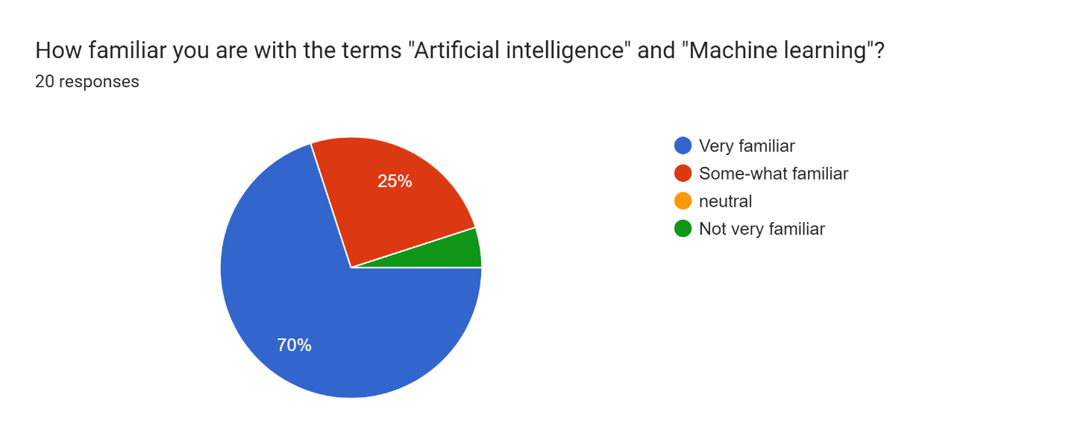

70% of the responses are very familiar with the terms of AI (Artificial Intelligence) and ML (Machine learning). The others are some what familiar with it maybe because they have not worked with AI and ML that much, and the 5% are people who are not very familiar with AI and ML.

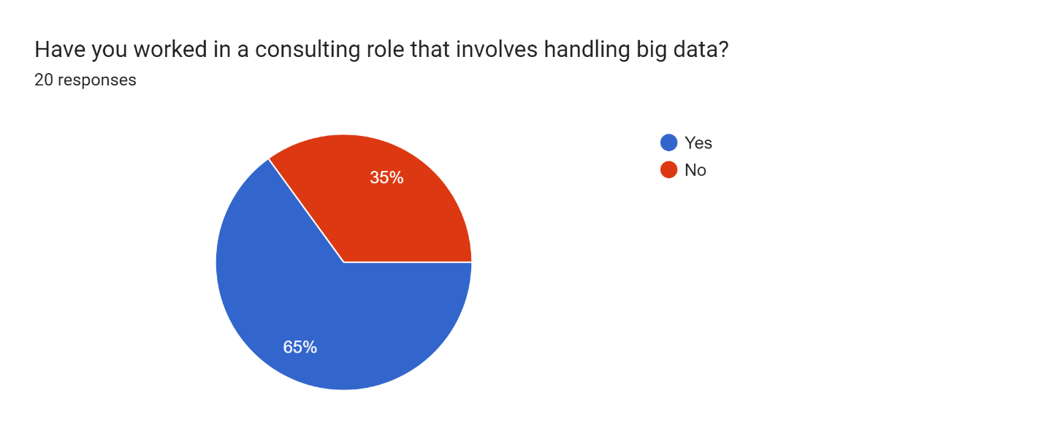

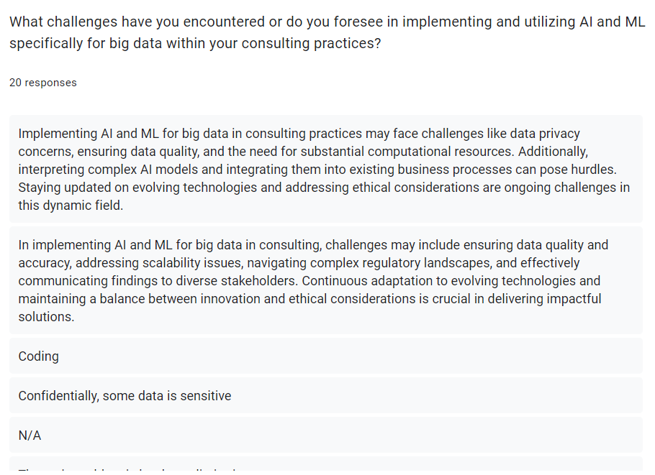The pie percentage shows that 65% of them are worked or wokring in a consulting role, and the other are the Technical/IT whom never worked in as consultants.

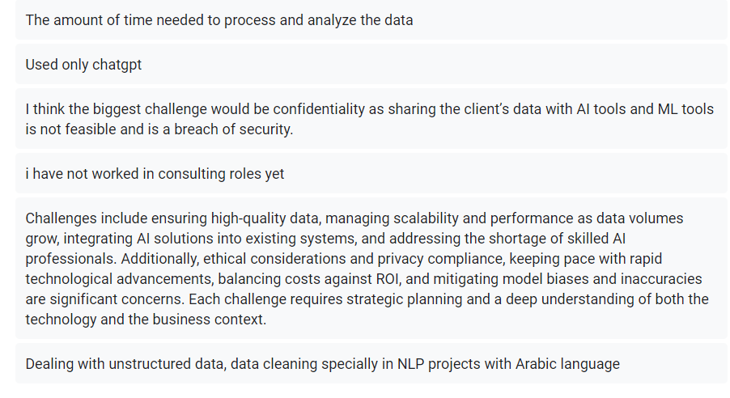

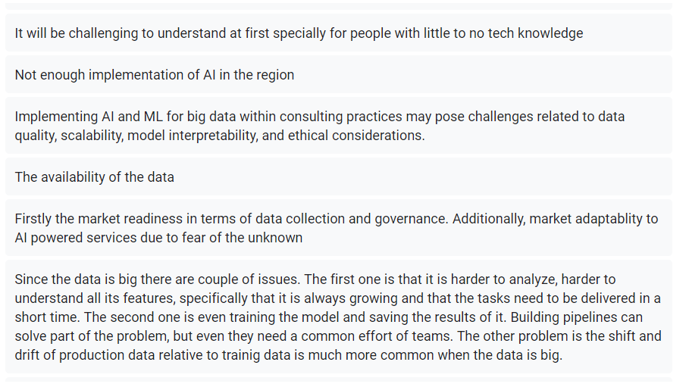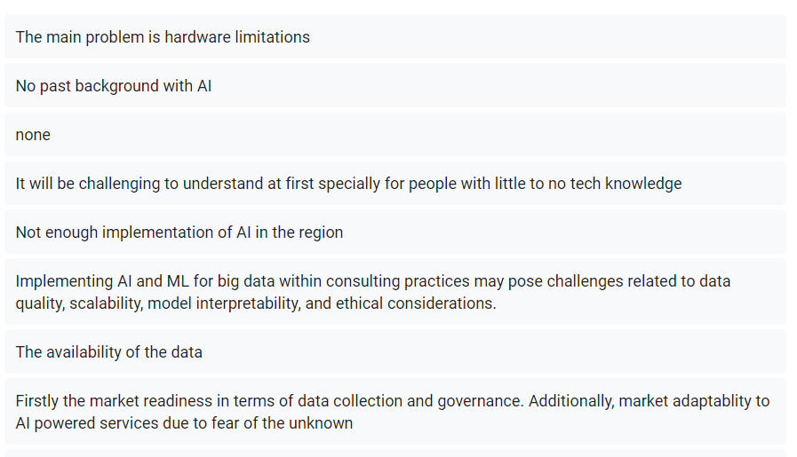

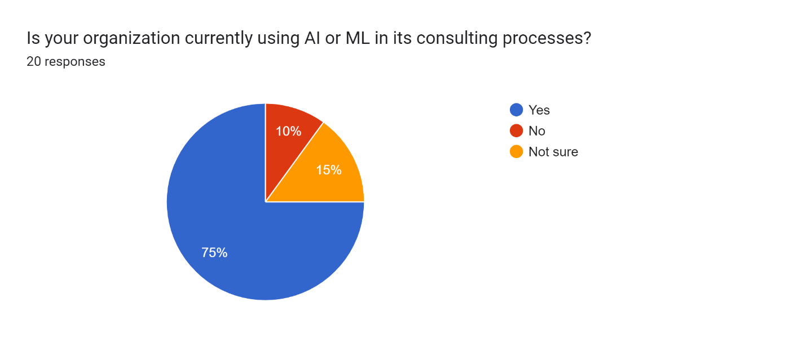

As it is shown in the above pie chart, 75% of the companies uses AI and ML in their system, 15% are not sure if they are using AI and ML maybe because they haven’t dealt with these technologies, and the 10% they don’t use AI and ML yet in their companies.

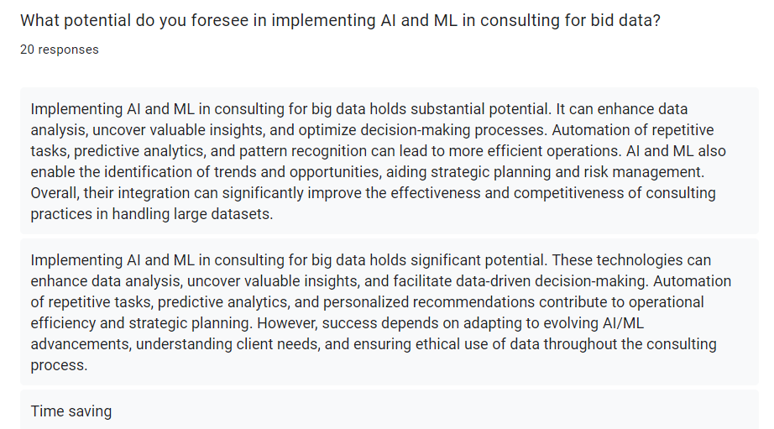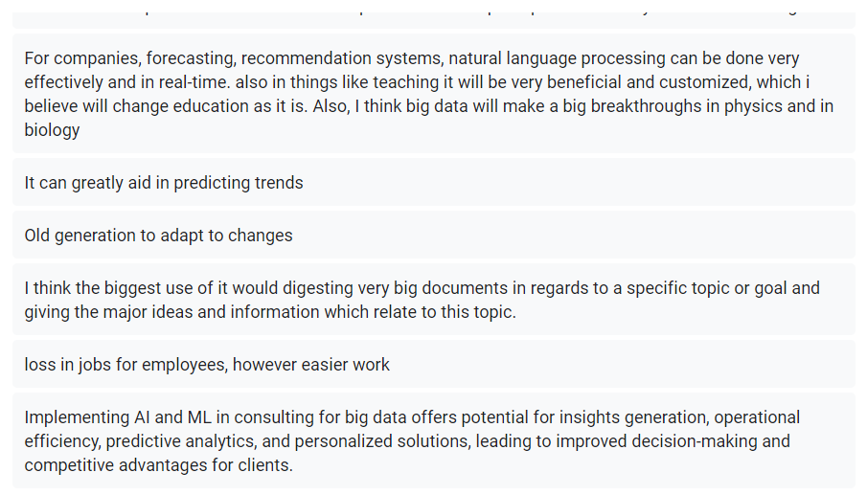

The feedback on AI and ML implementation in consulting for big data underscores its capacity to revolutionize data analysis and decision-making. It emphasizes benefits like automation, predictive analytics, and personalized solutions while noting the transformative impact on various sectors. However, there's an awareness of challenges such as adaptation for some demographics and potential job displacement. Collectively, these responses paint a picture of AI and ML as pivotal yet complex tools in the future of data-driven industries.

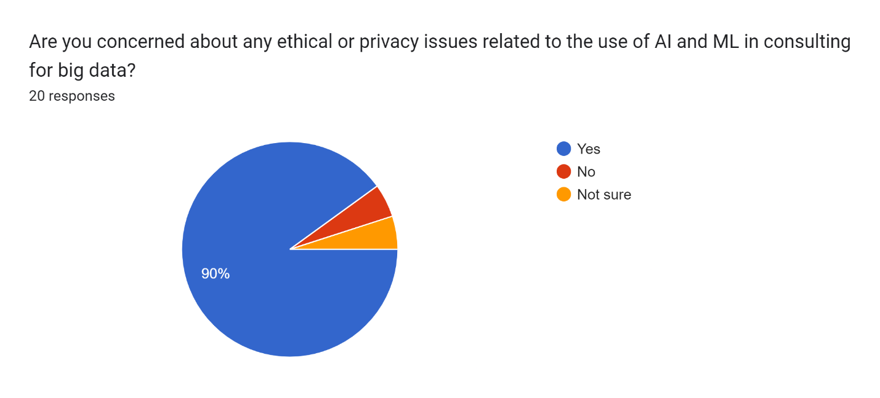

This investigation is crucial because it shows how concerned people are about the ethical and privacy ramifications in a sector that depends more and more on data-driven technologies. The overwhelming majority of respondents (90%) expressed worry, indicating that there is a strong need for ethical norms and privacy measures to be implemented along with responsible AI and ML techniques. For businesses to ensure responsible innovation in the consulting industry, sustain stakeholder trust, and direct policy development, this knowledge is essential.

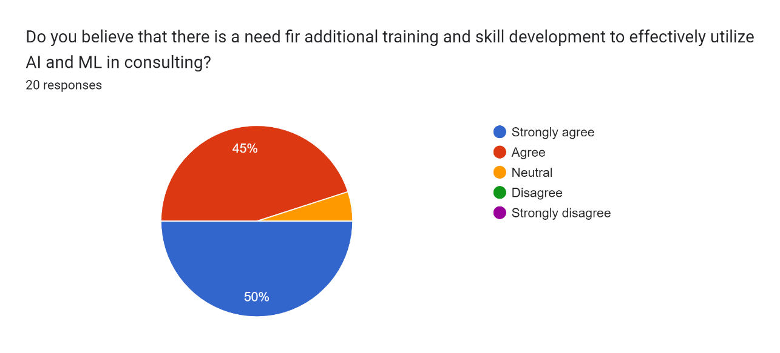

There is broad agreement on the necessity of upskilling in AI and ML for consulting, as evidenced by the pie chart, which reveals that 95% of respondents agree or strongly agree on this point.

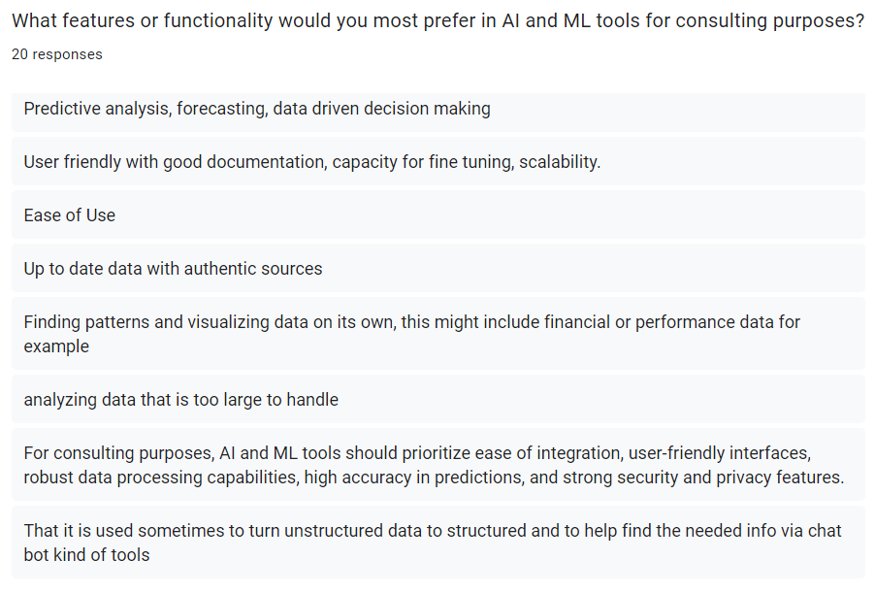

Top of Form

The survey's participants express a preference for AI and ML consulting tools that provide predictive capabilities, user-friendliness, and dependable data. They also stress the significance of robust data protection and intuitive design.

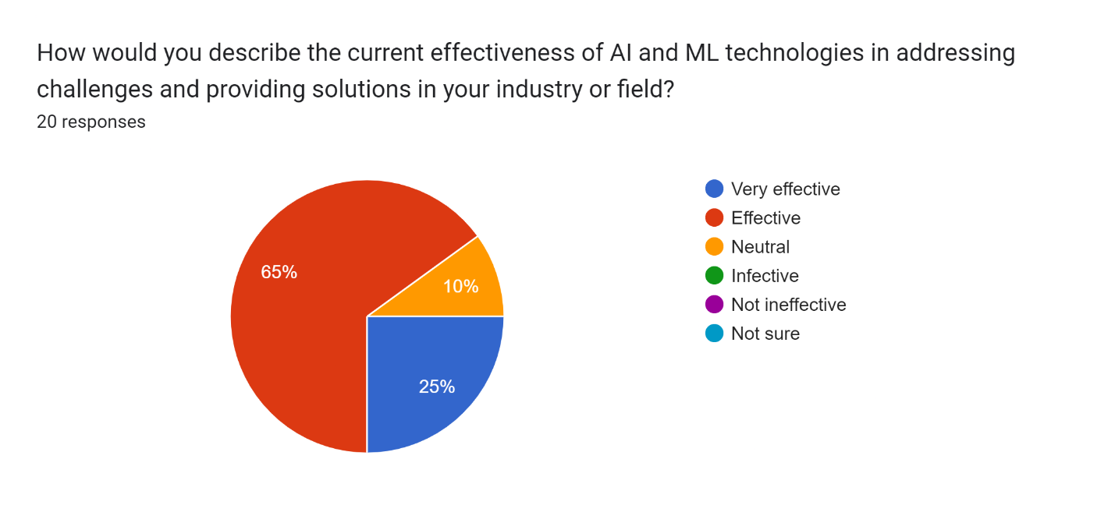

With 90% of respondents confirming the efficacy of these technologies, the data indicates a solid positive consensus among respondents regarding the influence of AI and ML in the sector. The lack of contradictory or ambiguous replies suggests that AI and ML are widely accepted as useful tools for solving problems and enhancing existing business procedures. This input could further encourage investment and attention on these technologies and help organizations and policymakers understand the perceived value of AI and ML in professional contexts.

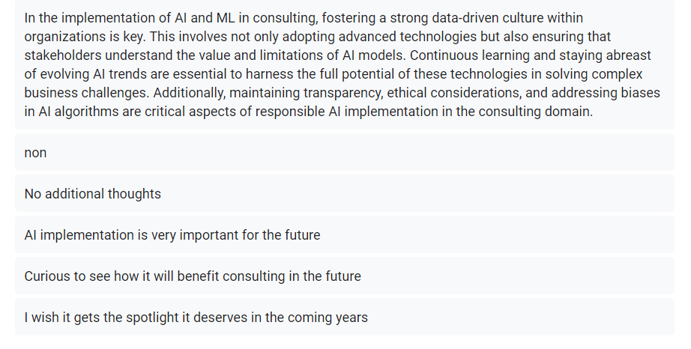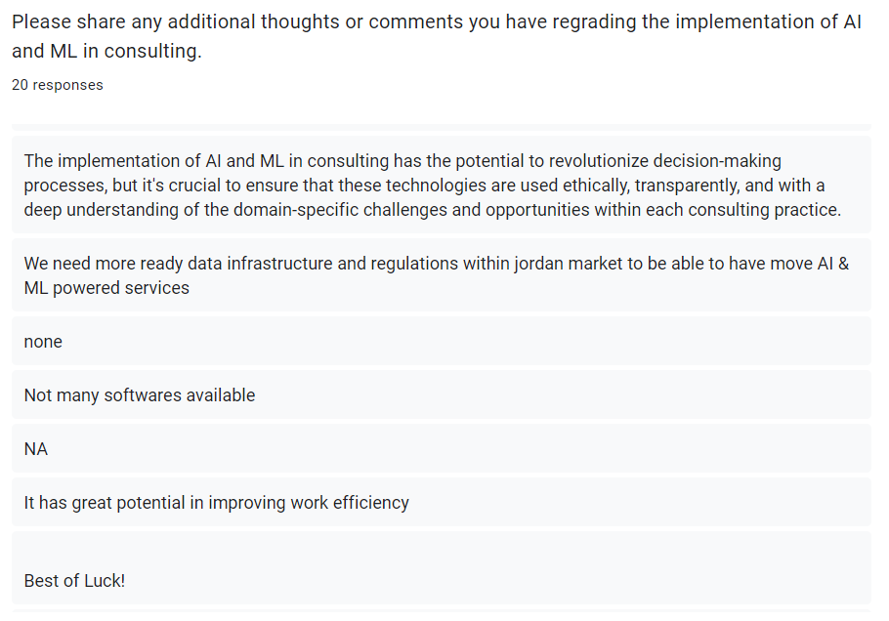

In conclusion, the results I collected from the survey aligned with the objectives of the research as well as the idea that was in mind before conducting the survey. In addition, the data that was collected showed great potential for Artificial Intelligence and Machine Learning in the consulting field. In fact, since the survey had reached people beyond the consulting field, it was shown from people interest that there is a great future and potential for integrating AI in many fields and aspects in our modern world. https://forms.gle/cs4fjSXhecm31Jh16

**Methodology, primary and secondary data**

**Qualitative Research methodology**: is while you are doing your research you do the qualitative technique, and it is all about focusing in collecting your data and analyzing it. Although, qualitative research focuses on understanding phenomena through rich, descriptive data. In qualitative research, researchers often employ techniques such as interviews, observations, and open-ended surveys to gather insights into individuals' experiences, perceptions, and behaviors.

**Quantitative Research Methodology**: is unlike the Qualitative methodology because it is used to understand concepts and experience as a set of hypotheses as it questions comes closed-ended. The closed ended questions is that the respondents have the option of selecting from predetermined answers, unlike the open-ended questions in which, it cannot be answered with simple yes or no, simply You gain a better understanding of customers' perspectives when you ask them questions rather than give canned answers.

What if we want to combine both of the qualitative and quantitative? We simply use mixed research methodology in which to integrate perspective and to create richer picture from data collection methods like interviews, documents and surveys depending on your overall research.

Through the process of researching the idea of consulting in integration with AI and ML, it had been made sure to pick the right data. Primary data is composed of information that is described as firsthand collected directly for the goal of the research. It was crucial in giving a deep understanding of the industry of consulting. This approach was resembled through direct interaction with a manager at Deloitte. This engagement provided important insights into Deloitte’s utilization of AI and Machine Learning (ML) technologies, showing how important primary data is in capturing current practices in the consulting field.

While secondary data is composed of information that has been already collected via reports, journals, and any other publications. This data was utilized for understanding perspectives on the consulting field in general, but it lacked specificity and immediateness provided by primary data for a real-world scenario, as Deloitte’s private data cannot be shared on secondary recourses on the internet.

**Address access and ethical issues**:

When gathering primary and confidential data from Deloitte, I ran into a lot of obstacles. The main barrier was the underlying confidentiality agreements and privacy policies that limit public dissemination of this kind of information. This restriction made it much more difficult for me to obtain important data that I needed for my research.

I spoke with Deloitte's manager Saleh directly in order to overcome this obstacle. I had the good fortune to get in touch with Saleh, one of the managers, through relentless attempts, and he turned out to be a crucial asset in my data gathering endeavors. Saleh gave me access to the required information as long as she guaranteed my anonymity and secrecy.

I used machine learning (ML) and artificial intelligence (AI) technology to anonymize the data in accordance with these ethical guidelines. To avoid any potential identification, the names of businesses that had collaborated with Deloitte had to be changed. I also made sure that all personal names were removed from the research data. These precautions played a critical role in protecting Saleh's information and preserving the privacy of all parties.   
  
By using this strategy, I was able to get beyond the obstacles to access while simultaneously making sure that my research complied with the strictest ethical guidelines for data security and privacy. The encounter made clear how crucial it is to address access and ethical concerns in research through direct involvement and technical solutions.

**Tools utilized for data collection and analysis.**

For my study topic, I used surveys as my main means of data collecting. The selection of surveys was based on their ability to collect a broad variety of data from a heterogeneous group of participants. I was able to gather both qualitative and quantitative data using this method, giving me a better understanding of the perspectives, experiences, and motivations of the participants as well as easy-to-analyse quantitative data for trends and patterns.

By using surveys, I was able to gather data in an organized but adaptable manner that made it possible for me to swiftly and effectively reach a large audience. This was especially helpful in obtaining information that represented the many viewpoints of people in various roles and responsibilities within the framework of my study. Furthermore, the time and resources required for data collecting were greatly decreased by the capacity to distribute surveys online, resulting in a more efficient and economical research procedure.

In order to strengthen the validity and comprehensiveness of my research findings, I included mixed-methodology survey questions. Using a combination of quantitative and qualitative research methodologies, this methodology enabled me to measure and analyze variables quantitatively as well as investigate complicated phenomena more thoroughly. Through the use of mixed methodologies, I was able to take advantage of the advantages of both strategies, the qualitative components offered more in-depth understanding of the context and motivations behind the data, while the quantitative aspects gave a broad overview and generalizability of the findings.

For a number of reasons, using blended approaches turned out to be more effective than using just one. It made it possible for me to analyze the study questions in greater detail, which helped me triangulate the data and validate it. This method made it easier to investigate differences between the quantitative and qualitative data, leading to a deeper and more comprehensive comprehension of the study's subject. Furthermore, by offering several levels of proof to back up conclusions, it improved the validity and reliability of the research findings.

I successfully gathered a wide range of data that was deep in insight and broad in reach by including surveys with mixed-methodology questions into my research design. By using this methodological approach, I was able to address the study objectives in-depth and persuasively, which greatly improved the overall quality and effect of my work.

**Explain how the findings align with your research objectives and state the answers to your research questions**

My research's findings, which are in perfect alignment with the original research objectives, demonstrate the indispensable function that machine learning (ML) and artificial intelligence (AI) play in contemporary business operations. This is evident from the data analysis that was done using an appropriate analytical tool such as Delve, and Hotjar. My first research was centered on the use of AI and ML in the consulting industry. But, as my survey's sample size grew to include more businesses, it became clear that these technologies are used for far more than just consulting.

A more widespread application of AI and ML was seen in a number of disciplines, including IT, marketing, auditing, and logistics. Deloitte, the study's main subject, eloquently demonstrated this broad acceptance across a variety of industries by demonstrating how these technologies may be integrated to improve system performance and operational efficiency. my results show how AI and ML are being used more and more in industry, and they have an impact on many business operations.

With carefully crafted survey questions that align with my study research goals, the data gathered from my survey validated this tendency. This made guaranteed that the research on the creation and use of AI and ML in businesses was coherent. My research strategy demonstrated the increasing use of these technologies in improving work performance throughout the industry in addition to confirming the applicability of my research issue. This suggests that AI and ML have a substantial, wide-ranging impact on company operations, bridging conventional boundaries and changing numerous divisions.

Onion methodology:

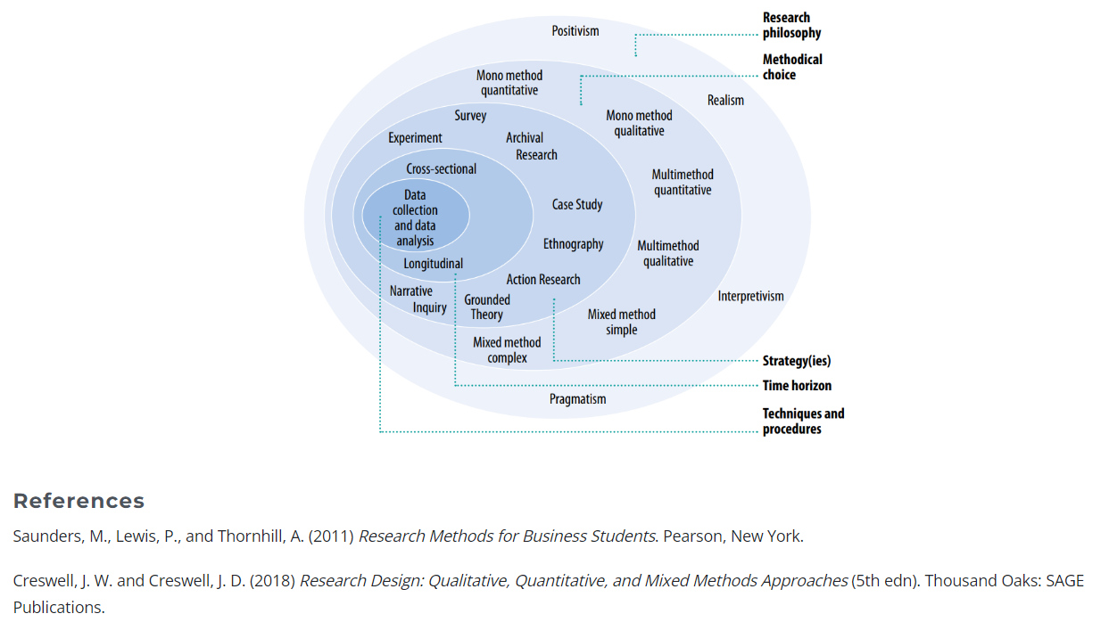

The onion methodology represents the stages involved in the development of my research work, which we see in the first layer it represents the research philosophy where I chose to be “realism”, and that is because the research philosophy is understood by a scientific investigation, although it is a perspective that believes that the truth of developing AI and ML in consulting filed exists and the research can undercover aspects of this scientific truth.

In the second layer that describe the methodical choice, I chose it to be the mixed method sample due to what I used in my survey which was the mixed method sample that contains qualitative and quantitative methodologies in order to collect a wider and a more comprehensive understanding of the results.

The third layer that contains strategies, I chose ‘survey’ as my research strategy because the study is focused on gathering opinions and information about the development of (AI) and (ML) in the consulting field. By conducting a survey, you're able to collect responses directly from people regarding their experiences and viewpoints. The survey is designed to include questions that will help people understand the extent to which individuals have worked with or encountered AI and ML, not just in consulting but in other fields as well.

In the fourth layer that talk about the time horizon, I found that in my research I was using ‘cross sectional’ and that is because I used a survey with a clear questions that conducted a one particular point in time, which means all of the survey responses I was able to study them at once without considering changes over time.

Last but not least, the techniques and procedures. The as I mentioned before I used the survey because I wanted to collect data from different people and on a large scale, after I gathered the data I was able to analyze all of the collected data from the survey in order to check if the research aligned with the idea I was thinking of from the starting of the research, and also I made sure to ensure the search ethical consideration to protect the private data I was told about.

Based on the analysis and findings, **present recommendations and justify them.**

Based on the comprehensive analysis and insightful findings of my research on the application of Artificial Intelligence (AI) and Machine Learning (ML) across various departments in companies, with a bit in focusing on Deloitte, several recommendations emerge. These recommendations are aimed at enhancing the integration and effectiveness of AI and ML technologies within corporate structures.

These justified by the clear evidence from my research showing that AI and ML technologies not only enhance operational efficiency and performance but also have the potential to transform various departments within companies.

1. **Increase Departmental AI and ML Initiatives**: Businesses want to think about extending their AI and ML projects outside conventional domains like consulting, considering the wide-ranging use and advantages of these technologies seen in departments like marketing, auditing, logistics, IT, and health care. This growth has the potential to improve productivity, encourage creativity, and provide the company a competitive edge in every area of operations.
2. **Invest in Tailored AI and ML Training**: Businesses should fund specific training initiatives for staff members in various areas in order to fully leverage the promise of AI and ML technology. By customizing these programs to meet the unique requirements and roles of every department, it is possible to boost staff productivity and performance by increasing their capacity to use these technologies.
3. **Develop Ethical principles for AI and ML Usage**: To ensure the responsible use of AI and ML technologies, it is imperative to develop clear ethical principles as these technologies become more integrated into company operations. To guarantee that AI and ML technologies benefit the business as well as society at large, these policies should cover data privacy, algorithmic bias, and transparency.
4. **Constantly Monitor and Assess AI and ML Impact**: Organizations should set up systems for continuing monitoring and assessment of AI and ML technologies' effects in order to guarantee their continued efficacy. This entails evaluating not just the technology performance but also the business results and worker happiness. Conducting routine evaluations can assist in improving AI and ML strategies and informing future investments in these technologies.

**Consider alternative research methodologies and lessons learnt in view of the outcomes**.

I could have used interview instead of using survey, because I was able to contact one of Deloitte’s manager using WhatsApp application and that could be enough in collecting data regarding the research subject. In addition, When evaluating the research methodology selection, it is worth noting that speaking with a management at Deloitte might have yielded insightful information about the use of AI and ML in a top company as Deloitte, offering a comprehensive viewpoint that a general poll might have overlooked.

While surveys gather broad information, interviews can provide a richer, more contextual perspective by delving into the specifics of implementation, difficulties, and results at Deloitte, and that could have been more than enough for me due to the data and the knowledge that I was able to collect from Deloitte’s manager because he has all the information needed regarding the research project.

**Provide critical replication and insight that result in recommended actions for improvements and future research consecrations**

Further studies should focus on interviews with experts in AI and ML to have insights into real-world scenarios and problems. In addition, actual datasets from companies should be analyzed to accurately show AI and ML operative benefits. Addressing issues related to privacy and ethics remains important for the responsible application of technology.

Further Recommendations consist of interacting with experts in an early stage who understand the topic from all aspects in the industry, making good use of the company datasets for a grounded analysis, utilizing mixed method approaches for a comprehensive understanding. This will make the research process more efficient and less recourse intensive.

**Critical evaluate research methodologies and processes in application to a computing research project to justify chosen research methods and analysis**

You used mixed approaches in your computing research project on AI and ML in the consulting industry, a deliberate decision that brought together quantitative and qualitative research to present a comprehensive picture. All survey questions were focused on AI and ML and were carefully crafted based on pertinent research from Google Scholar. This ensured that they aligned with the goal of your study, which is to explore the advancement of these technologies in consulting.

This meticulous methodology guaranteed that participants comprehended the context, augmenting the authenticity of your information. The significant involvement and the collection of 20 intelligent responses to the survey were probably made possible by your proactive strategy of distributing it personally and contacting important businesses in the business park to explain your idea and request participation.

You provide a comprehensive assessment of the existing and future prospects of AI and ML in the consulting industry by closely analyzing each response in light of your research goals. In the future, the research could be expanded in scope and depth by utilizing a wider range of data collection techniques and a larger sample size. This approach, which is reinforced by a targeted literature analysis, is in line with best standards for mixed-methods research and offers a strong foundation for your study of AI and ML in consulting.

**Critical analysis of the outcomes and make valid justified recommendations.**

The results of the poll, which show that 75% of the organizations using AI and ML are clearly demonstrating the major familiarity and integration of these technologies inside the consulting industry. The 15% of respondents who were unsure about how their organization will employ AI/ML literacy programs, however, point to a lack of internal communication and instruction and emphasize the urgent need for better programs. Strong ethical norms and privacy safeguards must be established in order to address the 90% of respondents' worries regarding ethical and privacy issues.

Since there is broad agreement regarding the significance of upskilling, businesses ought to spend money on thorough training to improve their employees' technical and strategic application abilities. Developers should concentrate on producing user-friendly AI and ML tools with robust predictive capabilities and data protection features, according to survey responses on tool functionality preferences.

Finally, there is strong evidence to support the recommendation that companies that are lagging behind should think about implementing AI and ML. By capitalizing on this positive consensus, investment can be encouraged and attention can be directed towards AI/ML tools that can provide innovative consulting practices and a competitive edge.

D3: on the reflective paper.Top of Form